|  |  |  |
| --- | --- | --- |
| Cairo University  Faculty of Engineering  Computer Engineering Department | | ­­­­CMPN450  Fall 2018 |
|  | **Pattern Recognition and Neural Networks.**  Lab 1 – Introduction to Python |  |

Given file “**StudentAnswers.csv**” that contains answers of 50 students to 8 MCQ questions and the gender of each student. Data in file is as shown in Figure1, where each row represents the answers of one student.

Gender Q1 Q2 Q3 Q4 Q5 Q6 Q7 Q8

.

.

.

.

Student 2

Student 1

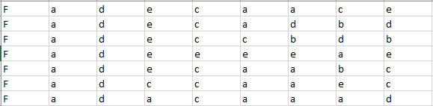

The “lab1.py” file contains some code that you can start with. The code reads the data from the file, and has some necessary data to do the requirements like the correct answer for each question

**Requirements:**

|  |  |
| --- | --- |
| 1. | Calculate the number of students who **didn't get the correct answer for the second question**. (Using ***for loops*** and ***vectorization***) |
| 2. | Calculate the **average score of the students** assuming that each correct answer gives 1 mark or otherwise 0 i.e. if a student answered 8 questions correctly, then he gets 8/8. (Using ***for loops*** and ***vectorization***) |
| 3. | Create **a bar plot** for the number of students who got the correct answer only for each question. |
| 4. | Create **a** **pie plot** for gender distribution of the students with labels. |